SIMATS ENGINEERING (SAVEETHA SCHOOL OF ENGINEERING)
Department of Computer Science and Engineering
CO1_AT3 — VISUALIZATION DESIGN EXERCISE

Course Code: | DSA0606 | Course Title: | Data Handling and Visualization
CO Assessed: | CO1 – Precision (BL2) | Assessment: | Assessment Tool 3 – Visualization Design
Weightage: | 40% of CIA | Total Marks: | 20 (2 Questions × 10 Marks)
CO1 Statement: | Understand the fundamental concepts, principles, and techniques of data visualization.(BL2)
Student Name: | Janani Priya G | Reg. No.: | 192324041
Section / Batch: | 2023 Btech AI & DS/ SLOT C | Date: | 28/07/2026

Code of Conduct
I Janani Priya G / 192324041 (Name / Reg No) certify that this submission is my original work and that I have adhered to the guidelines specified for this assessment. I understand that any violation of academic integrity rules will result in disciplinary action.

Signature of the Student: _________________________

Instructions
- This assessment contains 2 questions, each carrying 10 marks. Total: 20 Marks.
- No negative marking. Unanswered questions carry zero marks.
- No calculators or electronic devices permitted.
- Duration: 60 minutes.

Annexure A – VISUALIZATION DESIGN

PROBLEM 03 (A): CHART TYPE OF ORDINAL DATA

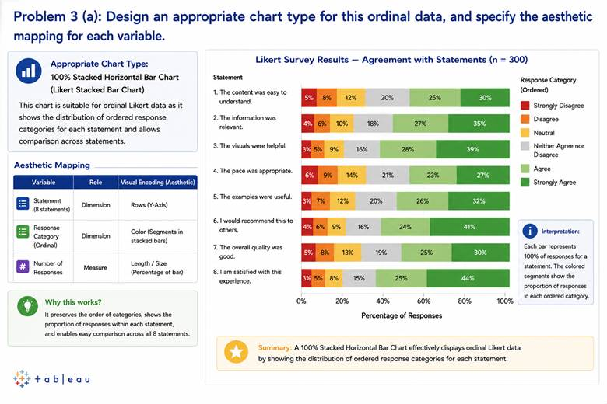

PROBLEM 03 (B): REINFORCE ORDERED NATURE CATEGORIES

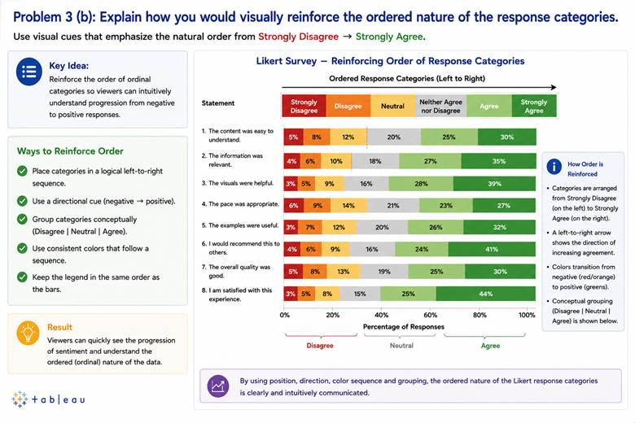

PROBLEM 03 (C ) DIVERGING SCALE :

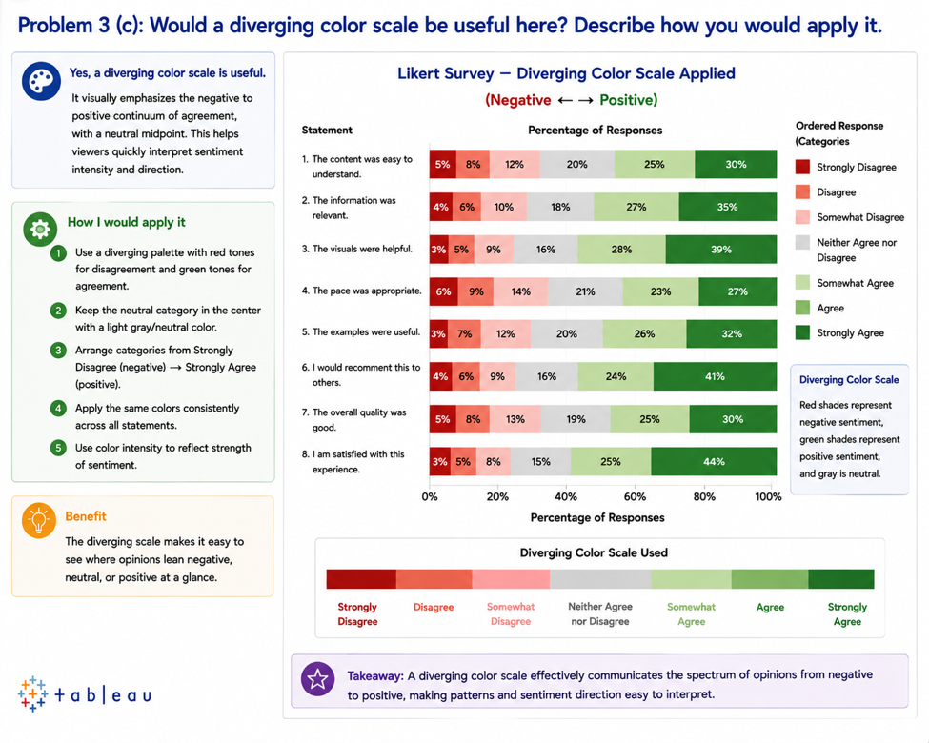

PROBLEM 13 (A): POLAR CHART LAYOUT TO EMPHASIZE THIS WEEKLY CYCLE

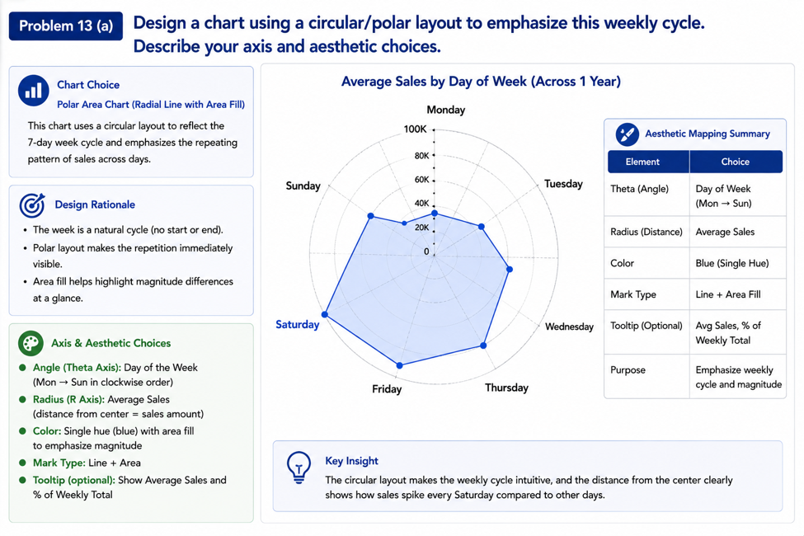
PROBLEM 13 (B) : LINEAR CARTESIAN LINE CHARTSPANNING THE FULL YEAR
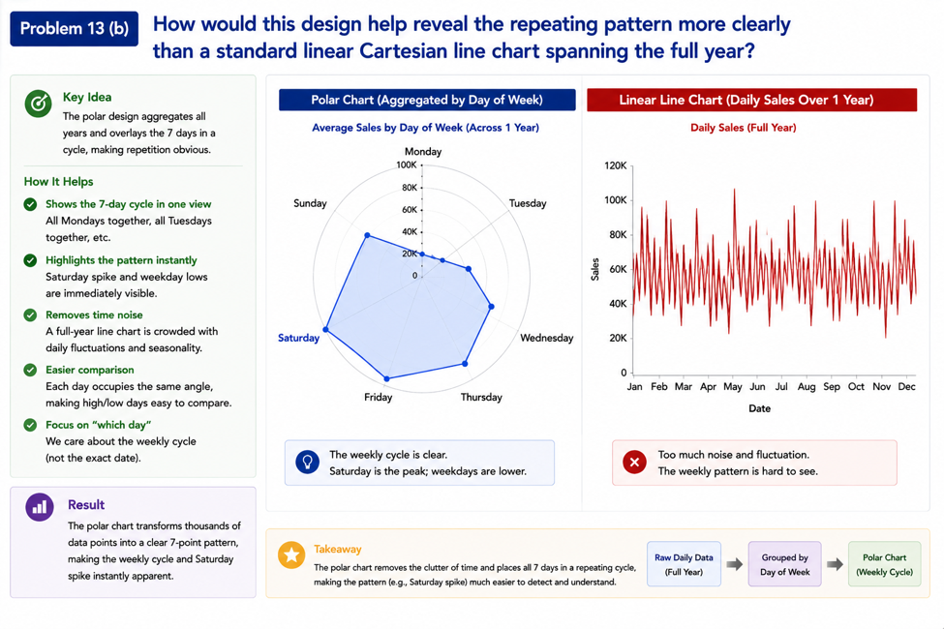

PROBLEM 13 (C ) : AGGREGATED BY DAY - OF - WEEK (ACROSS A YEAR)

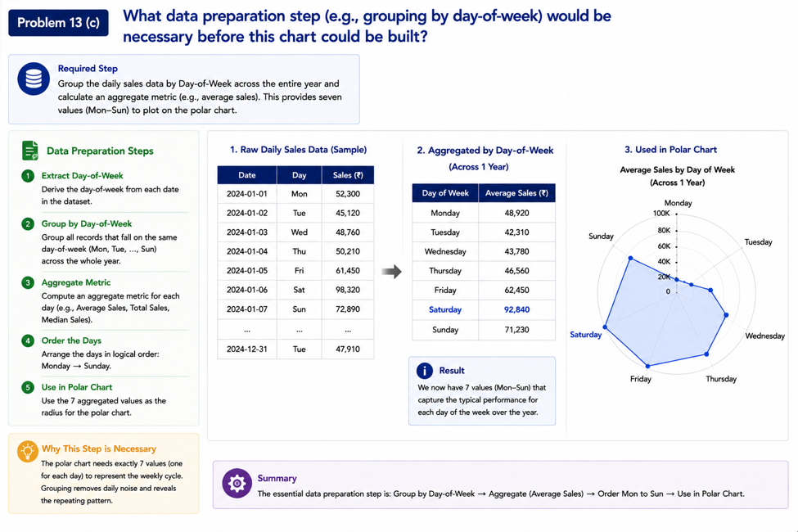

Faculty In-charge | Course Coordinator | Head of Department
Signature: _______________ | Signature: _______________ | Signature: _______________
Date: ___________________ | Date: ___________________ | Date: ___________________

